Nama : Elvaretta Salsabilla

NIM : 2241720116

No/Kelas : 14/TI-2H

LAPORAN PRAKTIKUM

1. Routing
2. Praktikum Basic Routing
3. Kode:

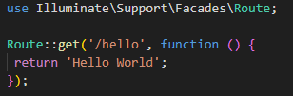

Output:

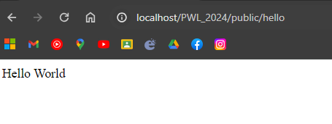

1. Kode:

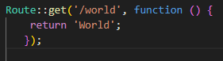

Output:

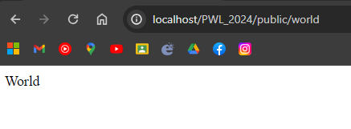

1. Kode:



Output:

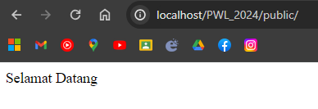

1. Kode:



Output:

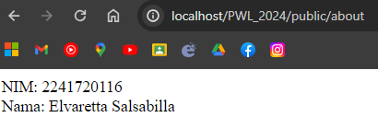

1. Praktikum Route Parameters
2. Kode:



Output:

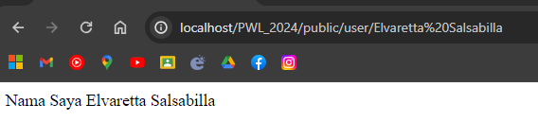

1. Kode:

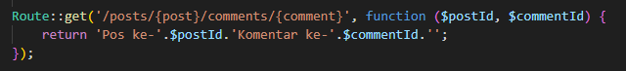

Output:

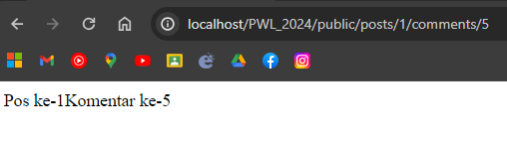

1. Kode:

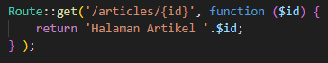

Output:

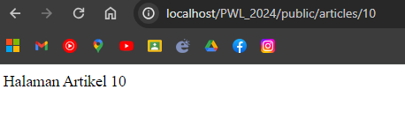

1. Praktikum Optional Parameters
2. Kode:



Output:

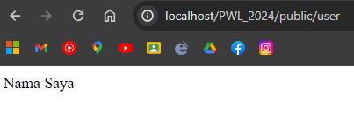

1. Kode:

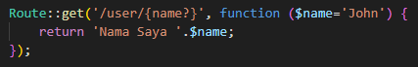

Output:

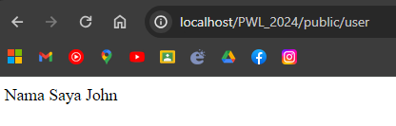

1. Controller
2. Praktikum Membuat Controller
3. Kode:



Output:



1. Kode:

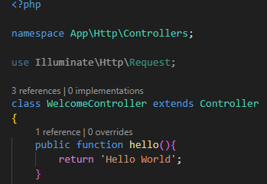



Output:

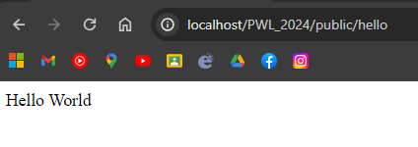

1. Kode:

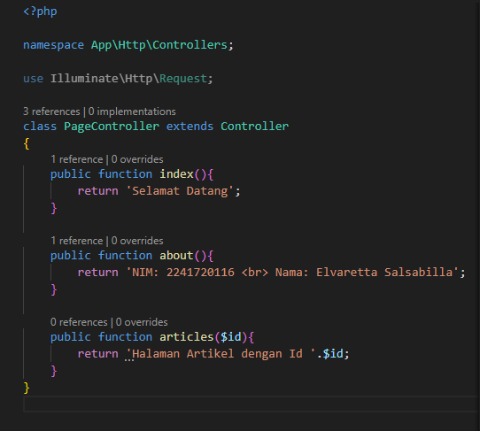

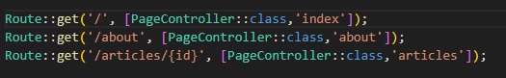

Output:

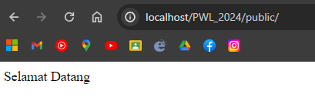

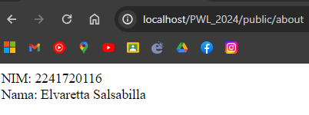

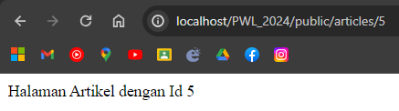

1. HomController

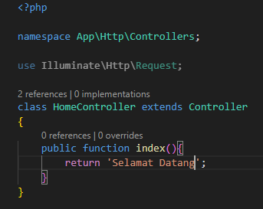



AboutController

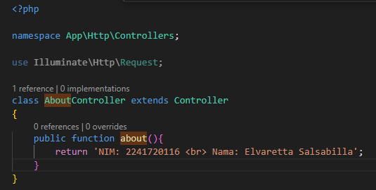



ArticleController

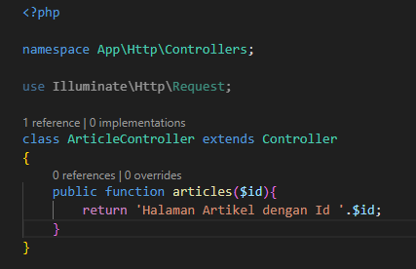



1. Praktikum Resource Controller
2. Kode:



Output:

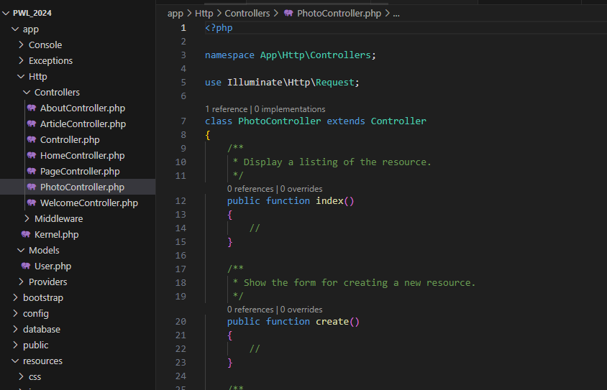

1. Kode:

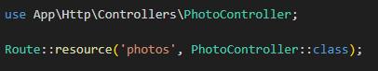

Output:

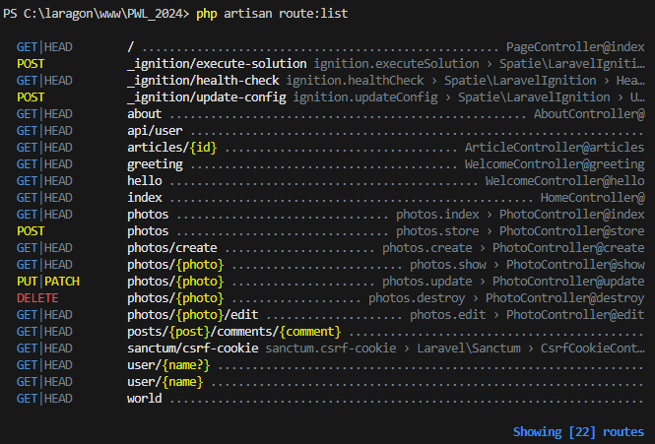

1. Kode:

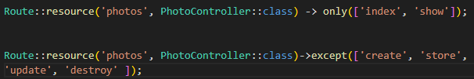

Output:

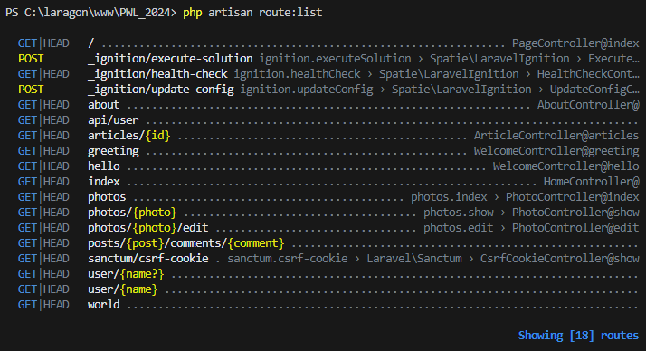

1. View
2. Praktikum membuat view
3. Kode:

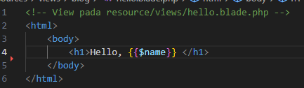



Output:

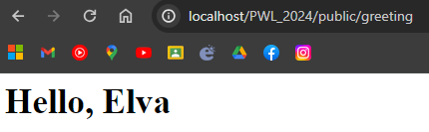

1. Praktikum View dalam Direktori
2. Kode:

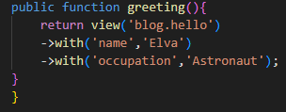



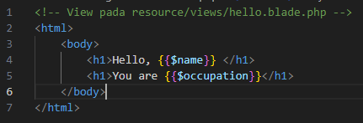

Output:

